Insurance Models

Kuei

# Social Demographics

## Demographics summary

| **Social Demographics** | **Frequency (%)** |
| --- | --- |
| Gender |  |
| Female | 27 (40%) |
| Male | 41 (60%) |
| Age |  |
| Below 30 years | 25 (37%) |
| 30 - 39 years | 27 (40%) |
| 40 - 49 years | 11 (16%) |
| Over 50 years | 5 (7.4%) |
| Level of Education |  |
| Secondary | 9 (13%) |
| Diploma | 22 (32%) |
| Bachelor’s | 34 (50%) |
| Postgraduate | 3 (4.4%) |
| Occupation |  |
| CEO | 31 (46%) |
| Financial officer | 27 (40%) |
| Internal Auditor | 10 (15%) |
| Working Period |  |
| Less than 1 year | 6 (8.8%) |
| 1 - 5 years | 30 (44%) |
| 6 - 10 years | 21 (31%) |
| over 10 years | 11 (16%) |

## Gender

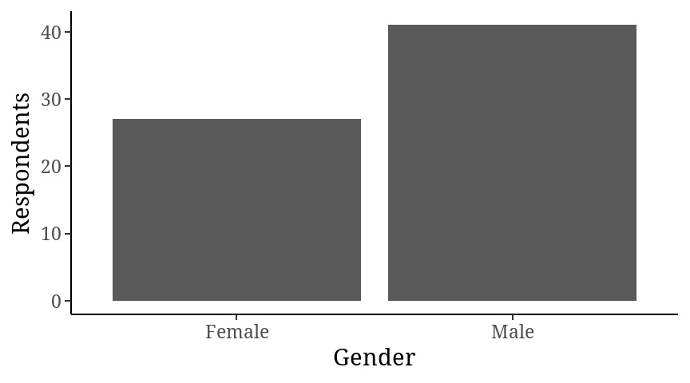

## Age

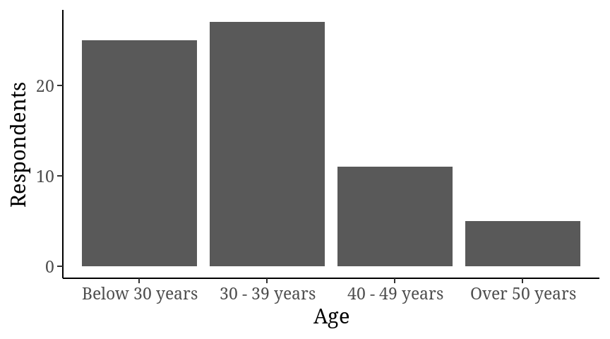

## Level of education

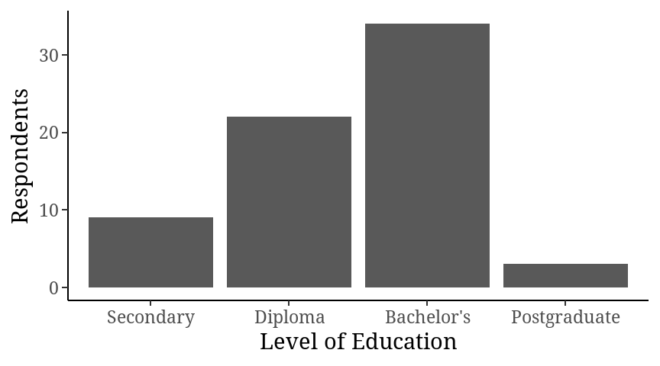

## Occupation

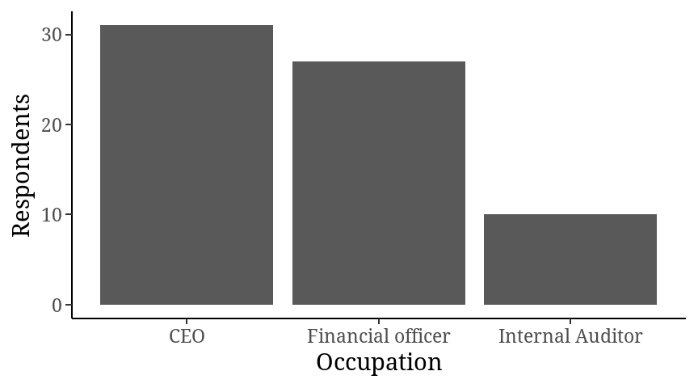

## Working Period

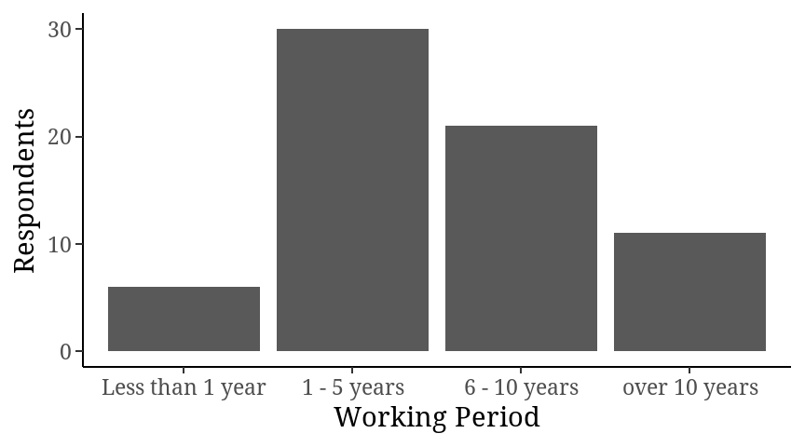

## Company Operation Period

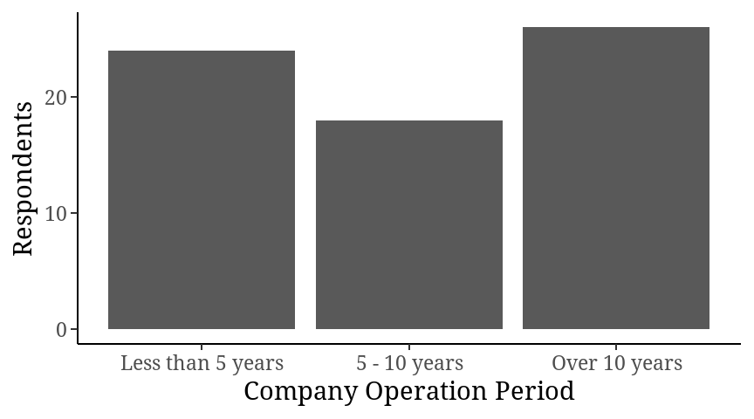

# Objective 1

## Overall Model

| **Characteristic** | **Beta** | **95% CI** | **p-value** |
| --- | --- | --- | --- |
| Financial innovation | 0.15 | -0.11, 0.41 | 0.2 |
| Longterm Investment | 0.02 | -0.74, 0.78 | >0.9 |
| Equity Investment | -0.31 | -0.75, 0.13 | 0.2 |
| Asset Base | -0.05 | -0.60, 0.51 | 0.9 |
| Gender |  |  |  |
| Female | — | — |  |
| Male | 0.21 | -0.41, 0.83 | 0.5 |
| Age |  |  |  |
| Below 30 years | — | — |  |
| 30 - 39 years | 0.51 | -0.34, 1.3 | 0.2 |
| 40 - 49 years | -0.27 | -1.1, 0.57 | 0.5 |
| Over 50 years | -0.13 | -1.3, 1.0 | 0.8 |
| Working Period |  |  |  |
| Less than 1 year | — | — |  |
| 1 - 5 years | -1.2 | -2.2, -0.11 | 0.032 |
| 6 - 10 years | -0.73 | -2.0, 0.49 | 0.2 |
| over 10 years | -0.22 | -1.7, 1.3 | 0.8 |
| Company Operation Period |  |  |  |
| Less than 5 years | — | — |  |
| 5 - 10 years | 0.72 | -0.08, 1.5 | 0.075 |
| Over 10 years | 0.08 | -0.73, 0.89 | 0.8 |
| Level of Education |  |  |  |
| Secondary | — | — |  |
| Diploma | 0.21 | -0.65, 1.1 | 0.6 |
| Bachelor’s | 0.23 | -0.61, 1.1 | 0.6 |
| Postgraduate | -0.10 | -1.5, 1.3 | 0.9 |
| Occupation |  |  |  |
| CEO | — | — |  |
| Financial officer | 0.01 | -0.63, 0.65 | >0.9 |
| Internal Auditor | -1.3 | -2.2, -0.38 | 0.006 |

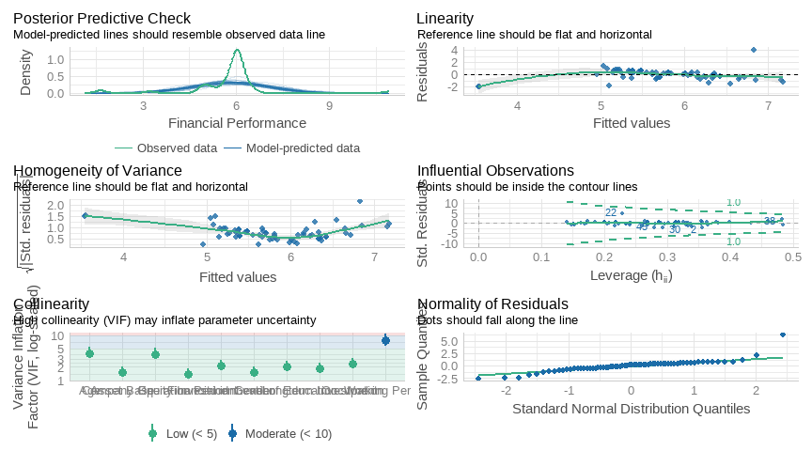

model_performance

| AIC | AICc | BIC | R2 | R2_adjusted | RMSE | Sigma |
| --- | --- | --- | --- | --- | --- | --- |
| 210.5984 | 228.4707 | 254.9885 | 0.3780775 | 0.1496162 | 0.8482848 | 0.9993051 |

## The effect of financial innovations on financial performance

| **Characteristic** | **Beta** | **95% CI** | **p-value** |
| --- | --- | --- | --- |
| Financial innovation | 0.24 | 0.05, 0.42 | 0.012 |

check_model(model_1)

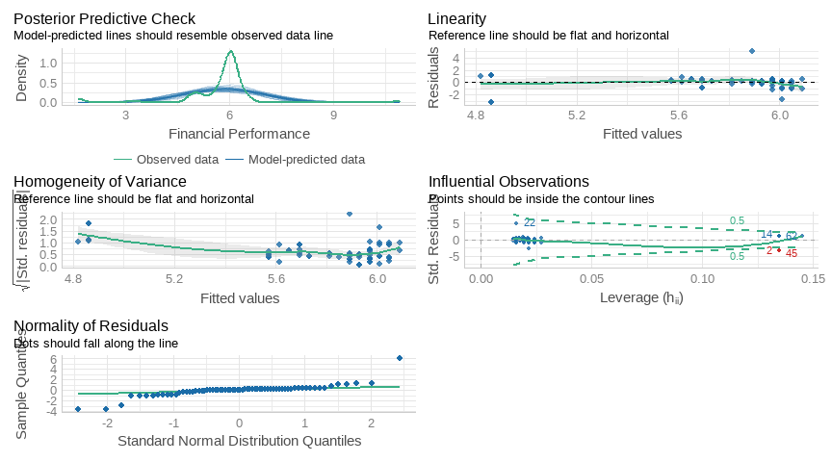

model_performance

| AIC | AICc | BIC | R2 | R2_adjusted | RMSE | Sigma |
| --- | --- | --- | --- | --- | --- | --- |
| 202.4133 | 202.7883 | 209.0719 | 0.09090697 | 0.07713283 | 1.025599 | 1.041023 |

## The effect of long- term investment on financial performance

| **Characteristic** | **Beta** | **95% CI** | **p-value** |
| --- | --- | --- | --- |
| Longterm Investment | -0.71 | -1.3, -0.13 | 0.018 |

check_model

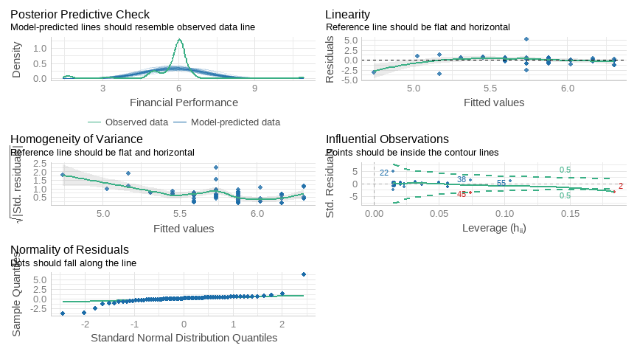

model_performance

| AIC | AICc | BIC | R2 | R2_adjusted | RMSE | Sigma |
| --- | --- | --- | --- | --- | --- | --- |
| 203.0764 | 203.4514 | 209.7349 | 0.08199911 | 0.06809 | 1.030612 | 1.046111 |

## The relationship between equity investment and financial performance

| **Characteristic** | **Beta** | **95% CI** | **p-value** |
| --- | --- | --- | --- |
| Equity Investment | -0.30 | -0.70, 0.10 | 0.14 |

check_model

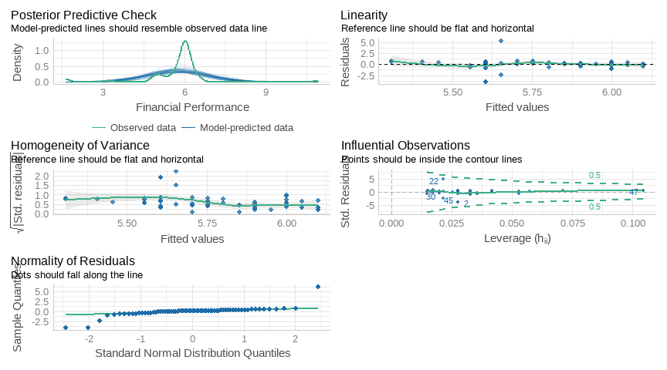

model_performance(model_3) %>% gt()

| AIC | AICc | BIC | R2 | R2_adjusted | RMSE | Sigma |
| --- | --- | --- | --- | --- | --- | --- |
| 206.6516 | 207.0266 | 213.3101 | 0.03244263 | 0.01778267 | 1.058064 | 1.073976 |

## The moderating effect of asset base relationship between financial management determinants and performance

| **Characteristic** | **Beta** | **95% CI** | **p-value** |
| --- | --- | --- | --- |
| Asset Base | -0.34 | -0.81, 0.14 | 0.2 |

check_model

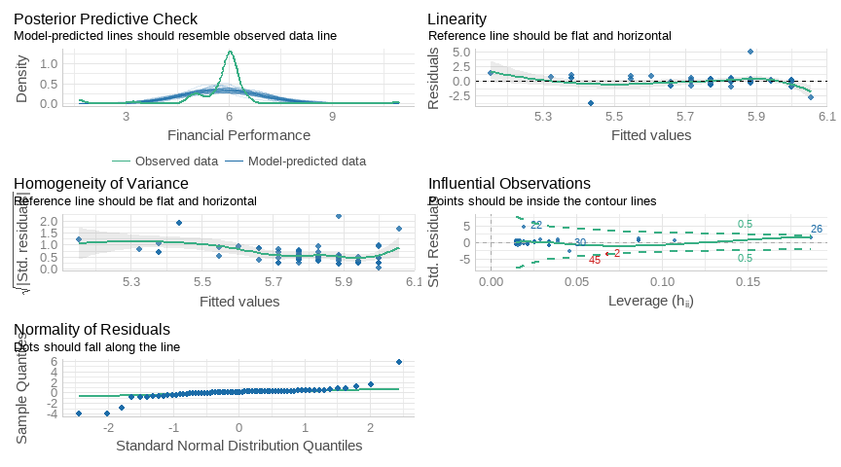

anova(model_4) %>% gt()

| Df | Sum Sq | Mean Sq | F value | Pr(>F) |
| --- | --- | --- | --- | --- |
| 1 | 2.325923 | 2.325923 | 2.010553 | 0.1609127 |
| 66 | 76.352574 | 1.156857 | NA | NA |

model_performance

| AIC | AICc | BIC | R2 | R2_adjusted | RMSE | Sigma |
| --- | --- | --- | --- | --- | --- | --- |
| 206.8537 | 207.2287 | 213.5122 | 0.02956237 | 0.01485877 | 1.059638 | 1.075573 |